AWS Building an Amazon VPC Using the VPC Wizard

Adhvitha Sivaganesh| CCNP

Purpose:

In this lab, I used the VPC Wizard to create virtual private cloud and create subnets and route tables with a NAT instance to create other infrastructure services. I created subnets and route tables and learned what their role is within a VPC. I created a NAT instance for the VPC and learned how to summarize the difference between a NAT instance and NAT gateway. At the end of the lesson, I got to learn what the route table is within the console and created the VPC with configurations.

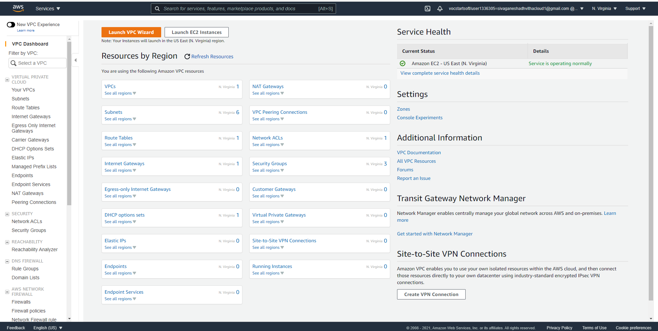

* I went into the VPC dashboard and clicked the button “Launch VPC Wizard”

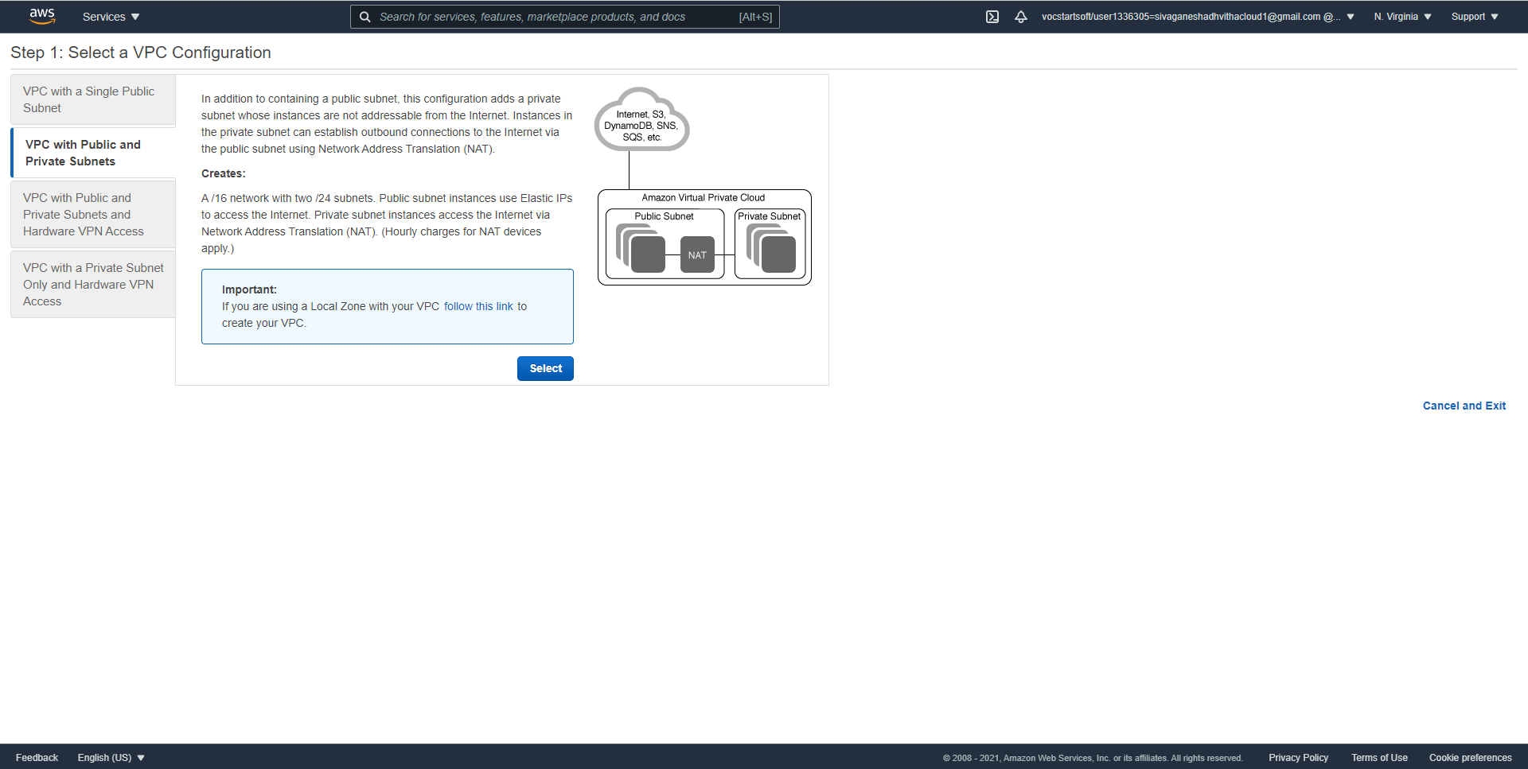

* After I went into the VPC Wizard I selected the VPC with public and private subnet option

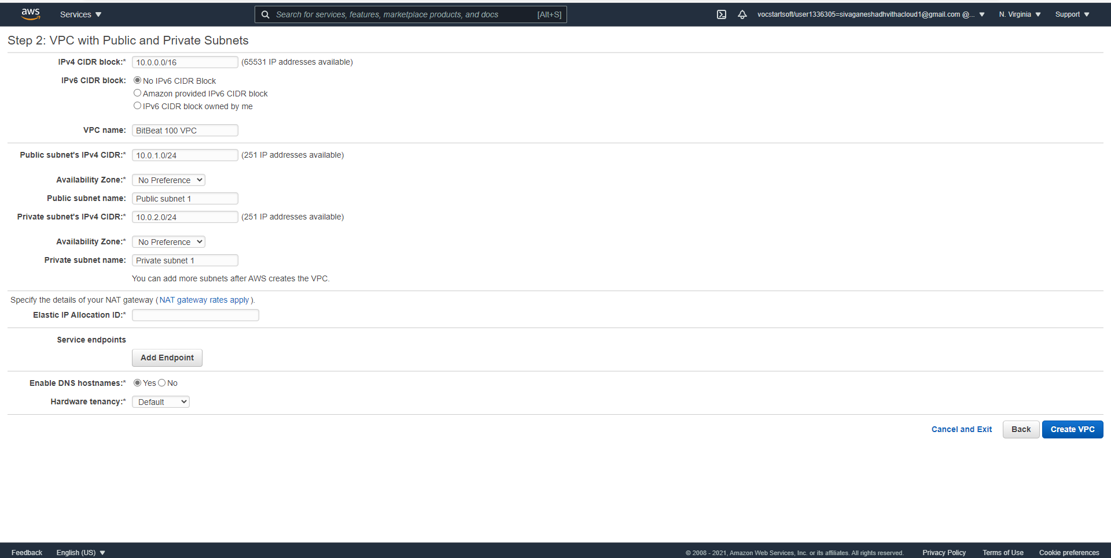

* I gave the name for the VPC which is “BitBeat 200 VPC in the VPC name box and added the IPv4 CIDR addresses.

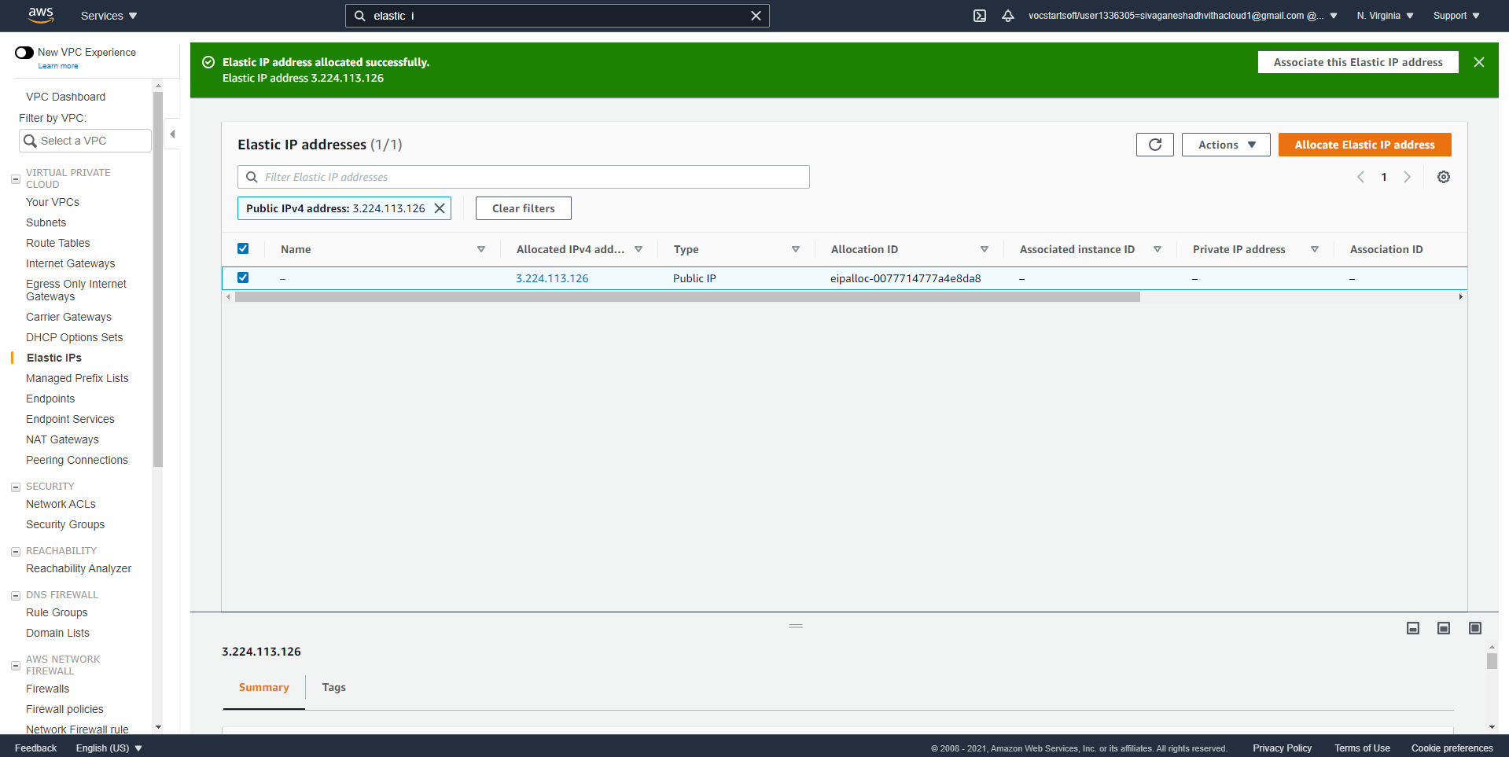

* Afterwards I created an Elastic IP address for the VPC

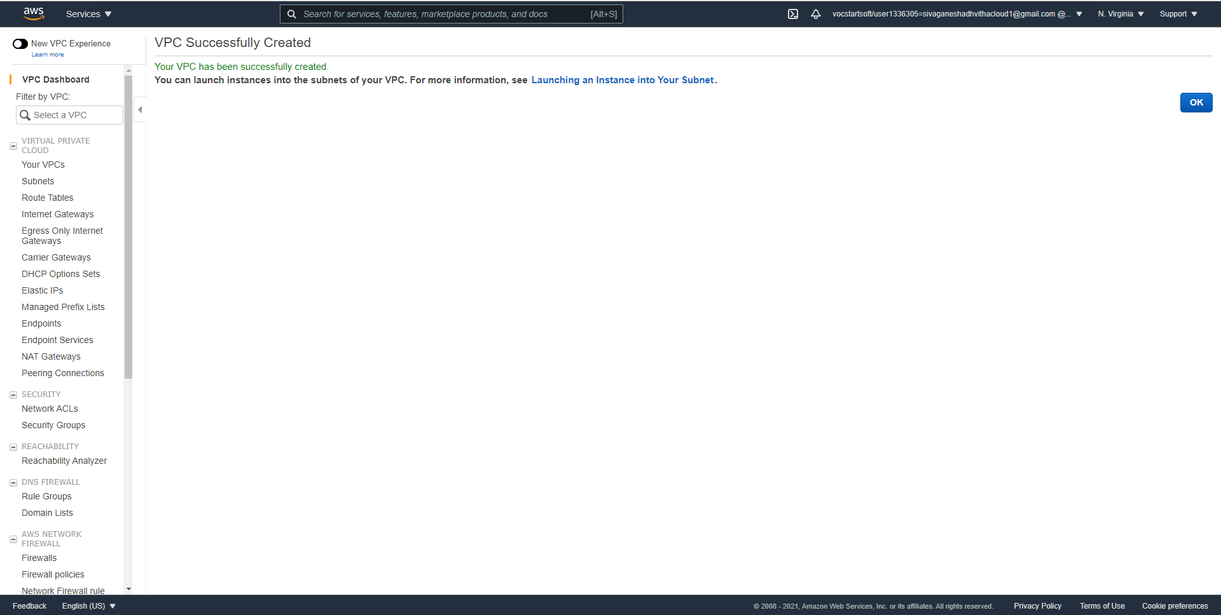

* When configuring everything and the elastic IP address, the VPC was created.

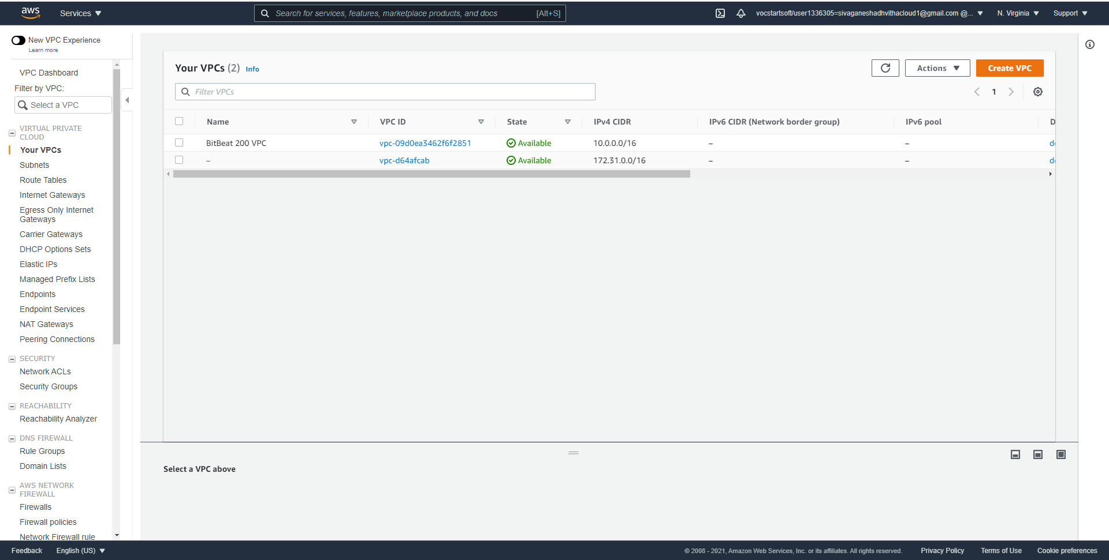

* These were configurations on the VPC I created called BitBeat 200 VPC

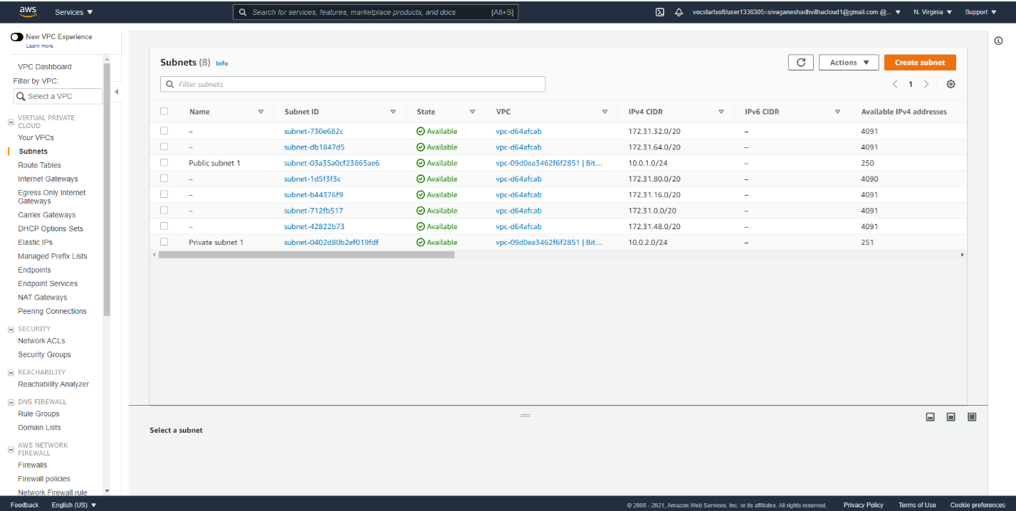

* These are the public and private subnets configured on the VPC

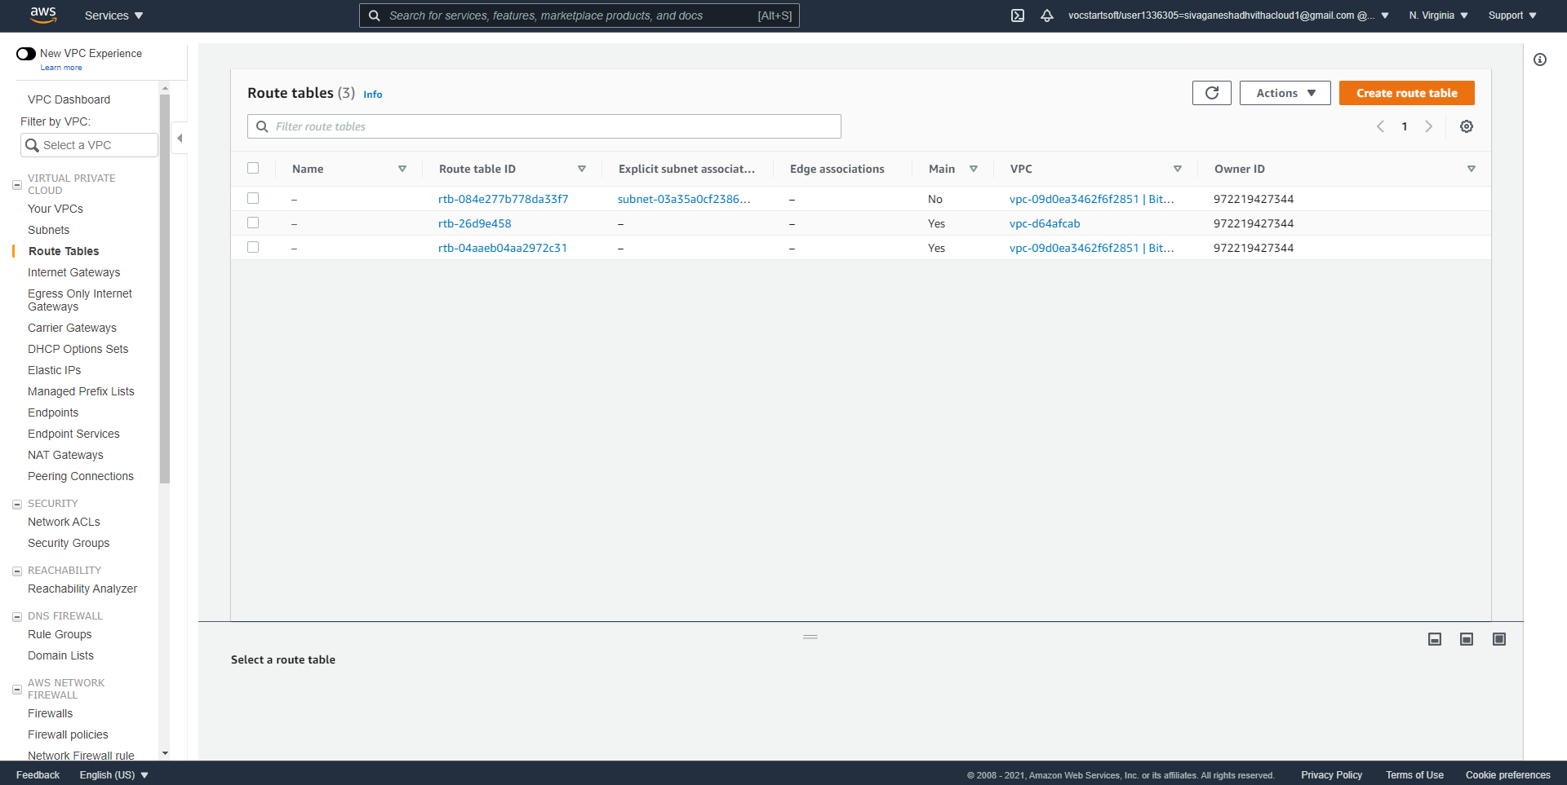

* I went into main route table and found out that the VPC ID was vpc-09d0ea3462f6f2851.

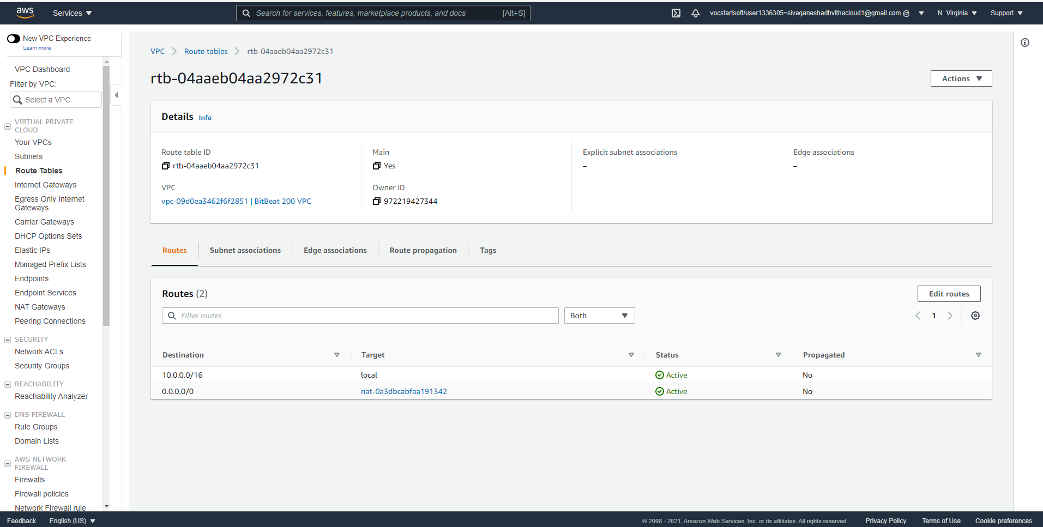

* The main route table ID was [rtb-04aaeb04aa2972c31](https://console.aws.amazon.com/vpc/home?region=us-east-1#RouteTables:routeTableId=rtb-04aaeb04aa2972c31).

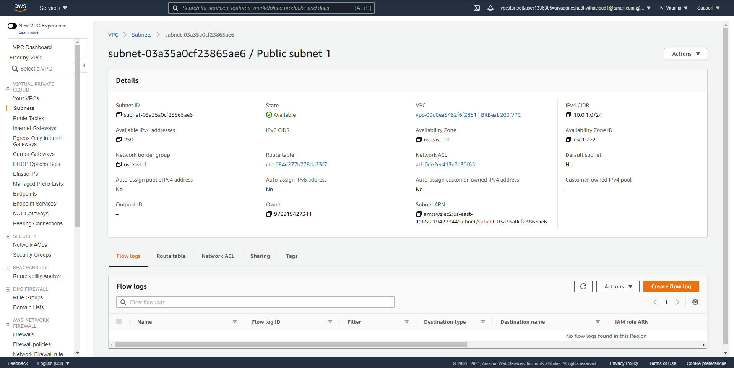

* These were the details of the public and private subnet that was configured on the Virtual Private Cloud

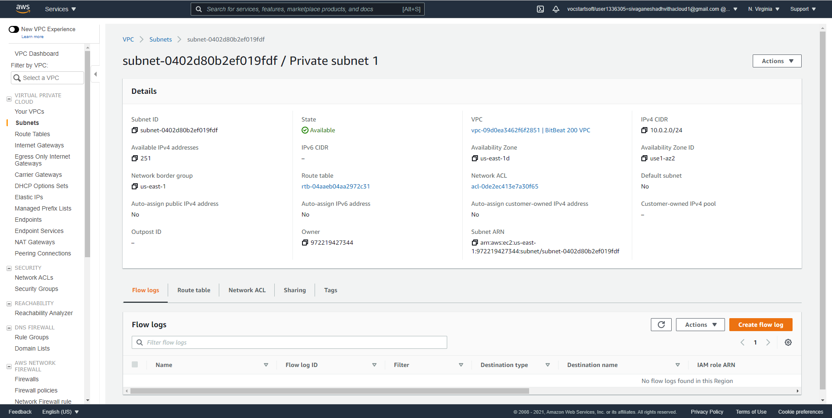

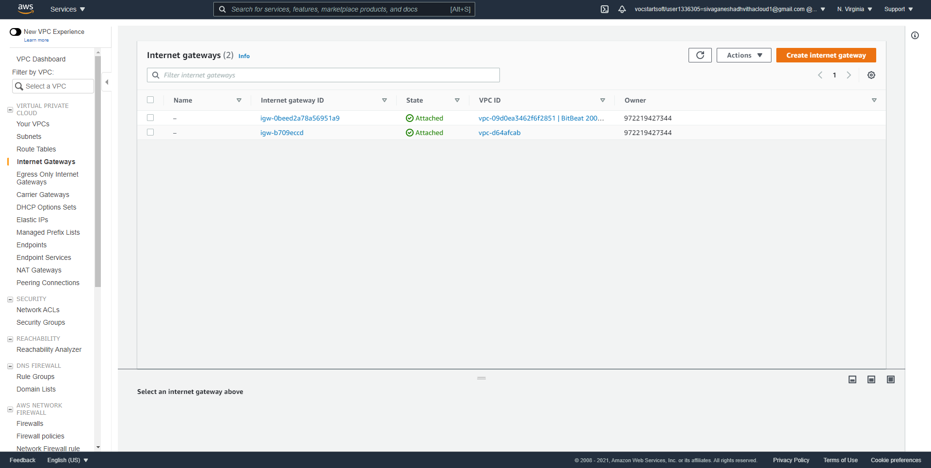

* These were the internet gateways on the Virtual Private Cloud.

Conclusion:

Overall, in this lesson I got to create a VPC and learned about the route table and configurations on the VPC. I learned that the route table controls the routing for all subnets that are not explicitly associated with any other route table. I got to also configure the internet gateway for the VPC. In the end I created a VPC named BitBeat with subnets, route tables, and a NAT instance.